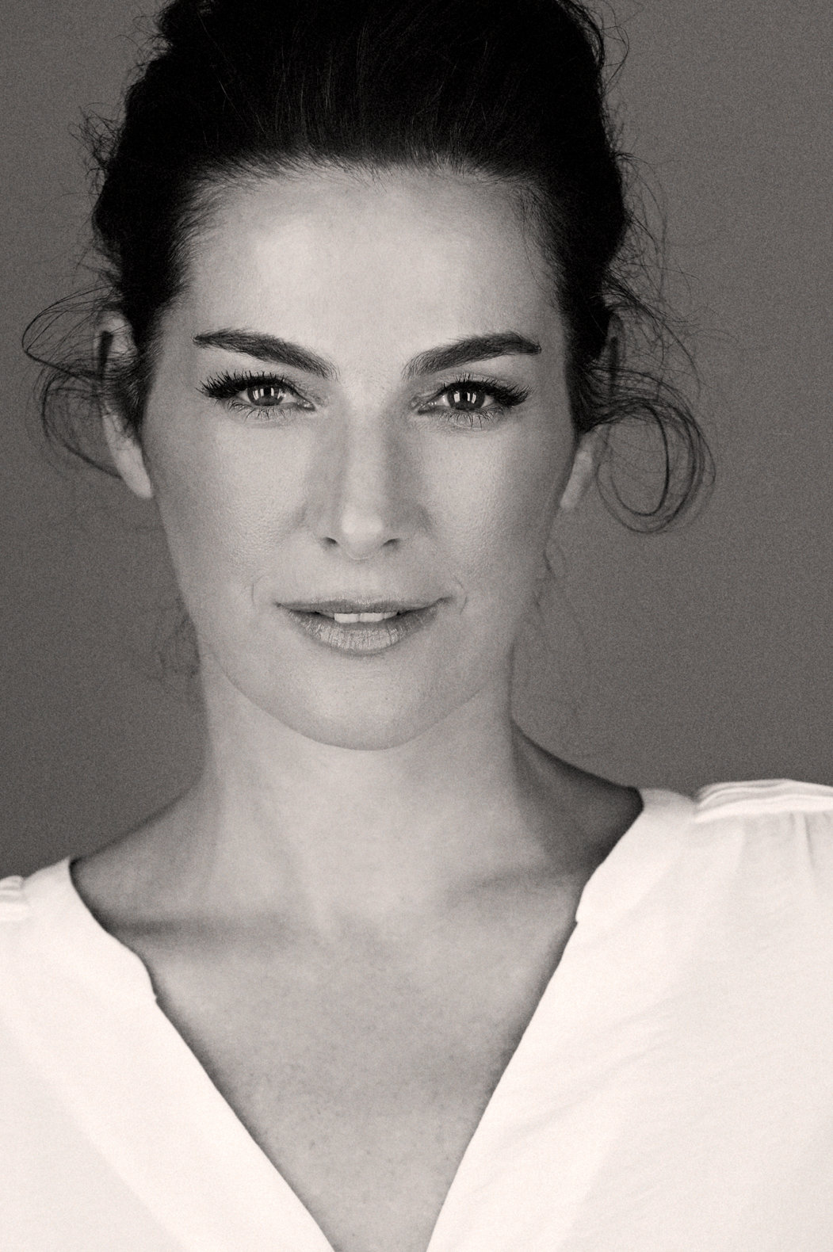

**AYELET ZURER** first garnered the attention of American audiences when Steven Spielberg cast her in the Oscar nominated film ***MUNICH***.  Zurer went on to star opposite Tom Hanks in the worldwide box office hit ***ANGELS & DEMONS***, directed by Ron Howard for Sony Pictures and opposite Russell Crowe ***MAN OF*** directed by Zack Snyder for Warner Bros.

One of Israel’s most acclaimed actresses. She won the ***Israeli Film Academy Award*** for her starring role as the title character in ***NINA’S TRAGEDIES.***

AYELETalso won the **Israeli Television Academy** Best Actress Award for ***IN THERAPY*** (adapted for HBO’s ***IN TREATMENT,***) for her role on ***BNEI ARUBA,*** (adapted for CBS’ ***HOSTAGES,*)** while also nominated for her role on ***SHTISEL*** (now on NETFLIX.) And the ***Golden Nymph award***at Monte Carlo, Europe's television award. Her lead role in the film ***MILADA*** earned her a nomination for best leading actress in the **Czech lions awards.**

AYELET’S other work includes- Sony’s ***VANTAGE POINT***, with Dennis Quaid and William Hurt, Samuel Goldwyn’s ***FUGITIVE PIECES*** with Stephen Dillane, Lawrence Kasdan’s ***DARLING COMPANION*** , Paul Schrader’s ***ADAM RESURRECTED*** with Jeff Goldblum and Willem Dafoe. ***LAST DAYS IN THE DESERT*** with Ewan McGregor. ***LAST KNIGHTS*** opposite Clive Owen. MGM’s ***BEN HUR*** And the MARVEL series for NETFLIX  ***DAREDEVIL*** opposite Vincent D’Onofrio. Next she will be seen in the lead role LOSING ALICE .

AYELET had illustrated two adult books, ***“SHORTS”*** *-* short stories by Paulo Coelho and the best seller ***“BADOLINA***” by Gabi Nitazn.

In 2018 She published her book- “***AS OF NOW”*** *which she written and illustrated.*